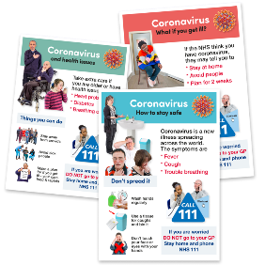 | Every one seems to be talking about the Coronavirus at the moment
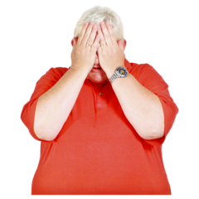 | Lots of people seem to be very worried
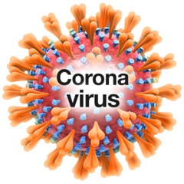 | This guide explains what is happening and what you need to do about Coronavirus
What’s going on?
North Lincolnshire Learning Disability Partnership Guide to Coronavirus

What is Coronavirus?
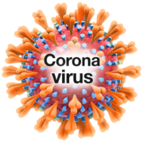 |  | Coronavirus is a new illness
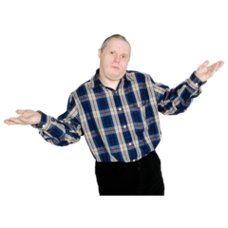 |  | So we don’t really know lots about it yet
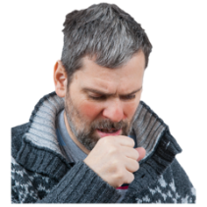 |  | It could be like a cold or flu
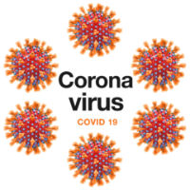 |  | It is sometimes called Covid-19
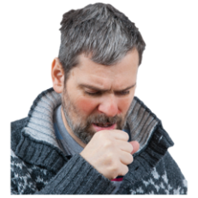 |  | Most people who catch it will get a cough
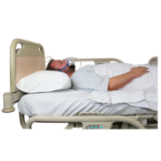 |  | If people have other health conditions they could become really poorly
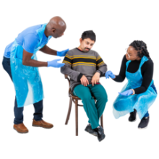 |  | So everyone needs to really careful not to catch and spread the virus
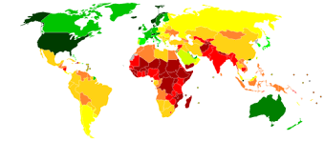 | Coronavirus has spread to lots of countries around the world
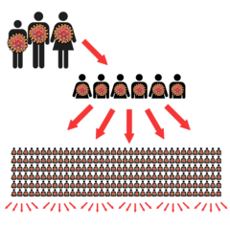 | Because so many people have caught it, it has been called a Pandemic
 | This just means that it is all over the world.

How do you catch Coronavirus?
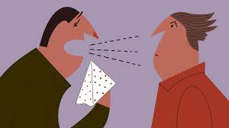 | You can catch it from being close to someone else with Coronavirus
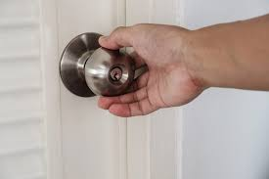 | You can catch it from hard surfaces where someone with Coronavirus has been
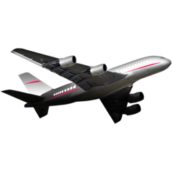 | If you have travelled abroad recently (in the last 2 weeks) you need to be extra careful

What do I need to look out for?
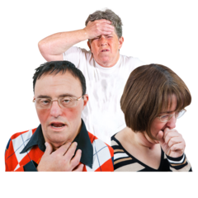 | If you have a fever
 | You have a new cough
 | You have cold or flu symptoms like a blocked or runny nose.
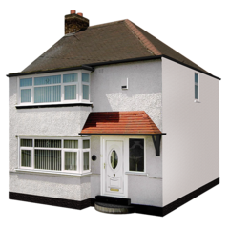 | If you have any of these things you will need to stay at home.

What do I need to do?
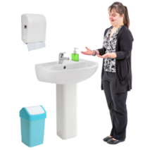 | Make sure you wash your hands lots
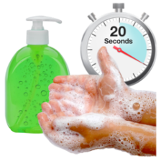 | There are lots of handwashing guides to make sure you do it right
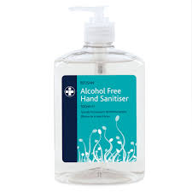 | You can also use hand sanitiser
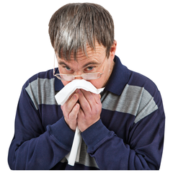 | Make sure you cough or sneeze into a tissue then throw it away
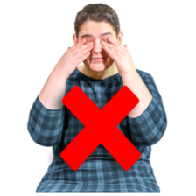 | Try not to touch your face too much

What have the government told me to do?
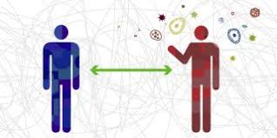 | The government want people to start ‘social-distancing’,
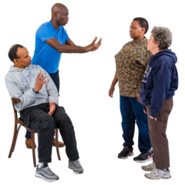 | This means not spending time with people you don’t live with
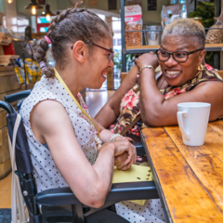 | The government have told people not to visit bars, cafes or restaurants
 | You might not be able to go to your usual activities
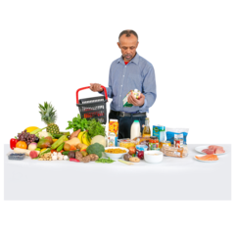 | You can still go to shops and buy the things you need
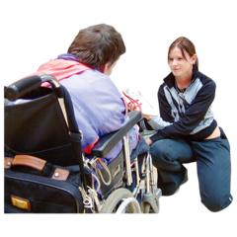 | It might be better to ask other people to go to the shops for you if you can
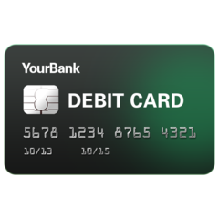 | If you can, use card to buy things so you don’t have to touch money.
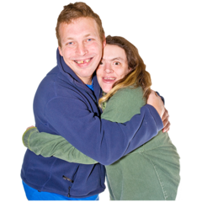 | Try not to touch other people for example hugging your friends in case they are feeling poorly
What should I do if I feel poorly?
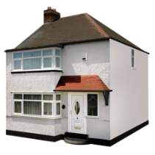 | If you have a temperature, a new cough or a cold you need to stay at home
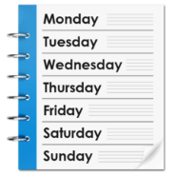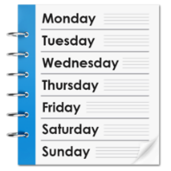 | You need to stay at home for 14 days
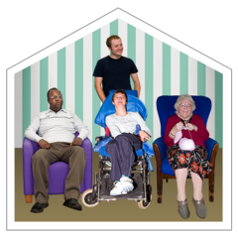 | Everyone you live with also has to stay at home too
 | This is called self-isolating
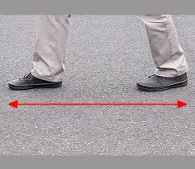 | You should try to stay at least 3 steps away from everyone else if you can
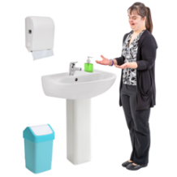 | If you can, clean the bathroom after you have used it.
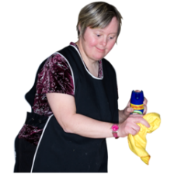 | Try to wipe down surfaces after you have touched them
 | Make sure you tell your support networks that you are staying at home.
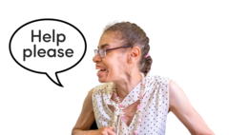 | Ask for help if you need it.
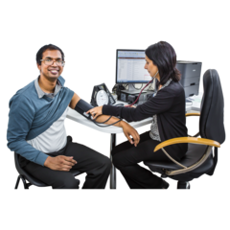 | You can still make appointments with your doctor if you feel poorly with something else.
Where can I get help?
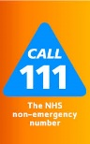 | You can call NHS 111 for advice when you feel poorly
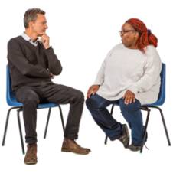 | If you receive support, talk to your support workers
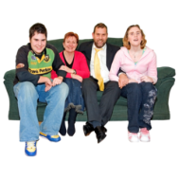 | Talk to your friends and family to make plans

