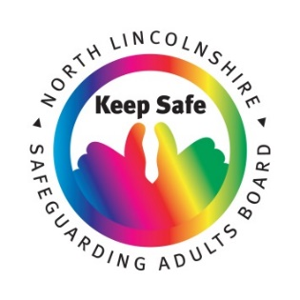

TELL SOMEONE AND BE SAFE FORM

**This form is for you to fill out if you are worried that someone is harming you, or someone else, and you would like some help with this and/or want it to stop**

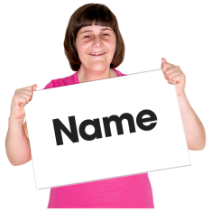

**Your**

**Name**

**Address**

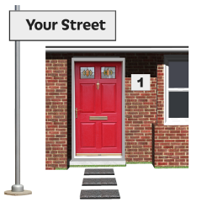

**Home number**

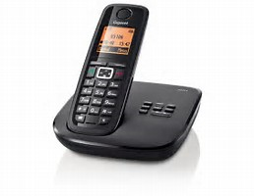

**Mobile number**

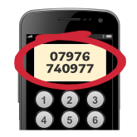

**Email address**



**Are you or someone else being harmed?**

**(Please circle your answer)**

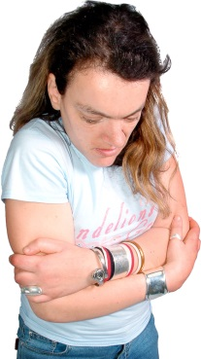



**Yes**



**No**

**Do you want it to stop?**

**(Please circle your answer)**



**Yes**





**No**

**Are you OK if someone comes to see you to help?**

**(Please circle your answer)**

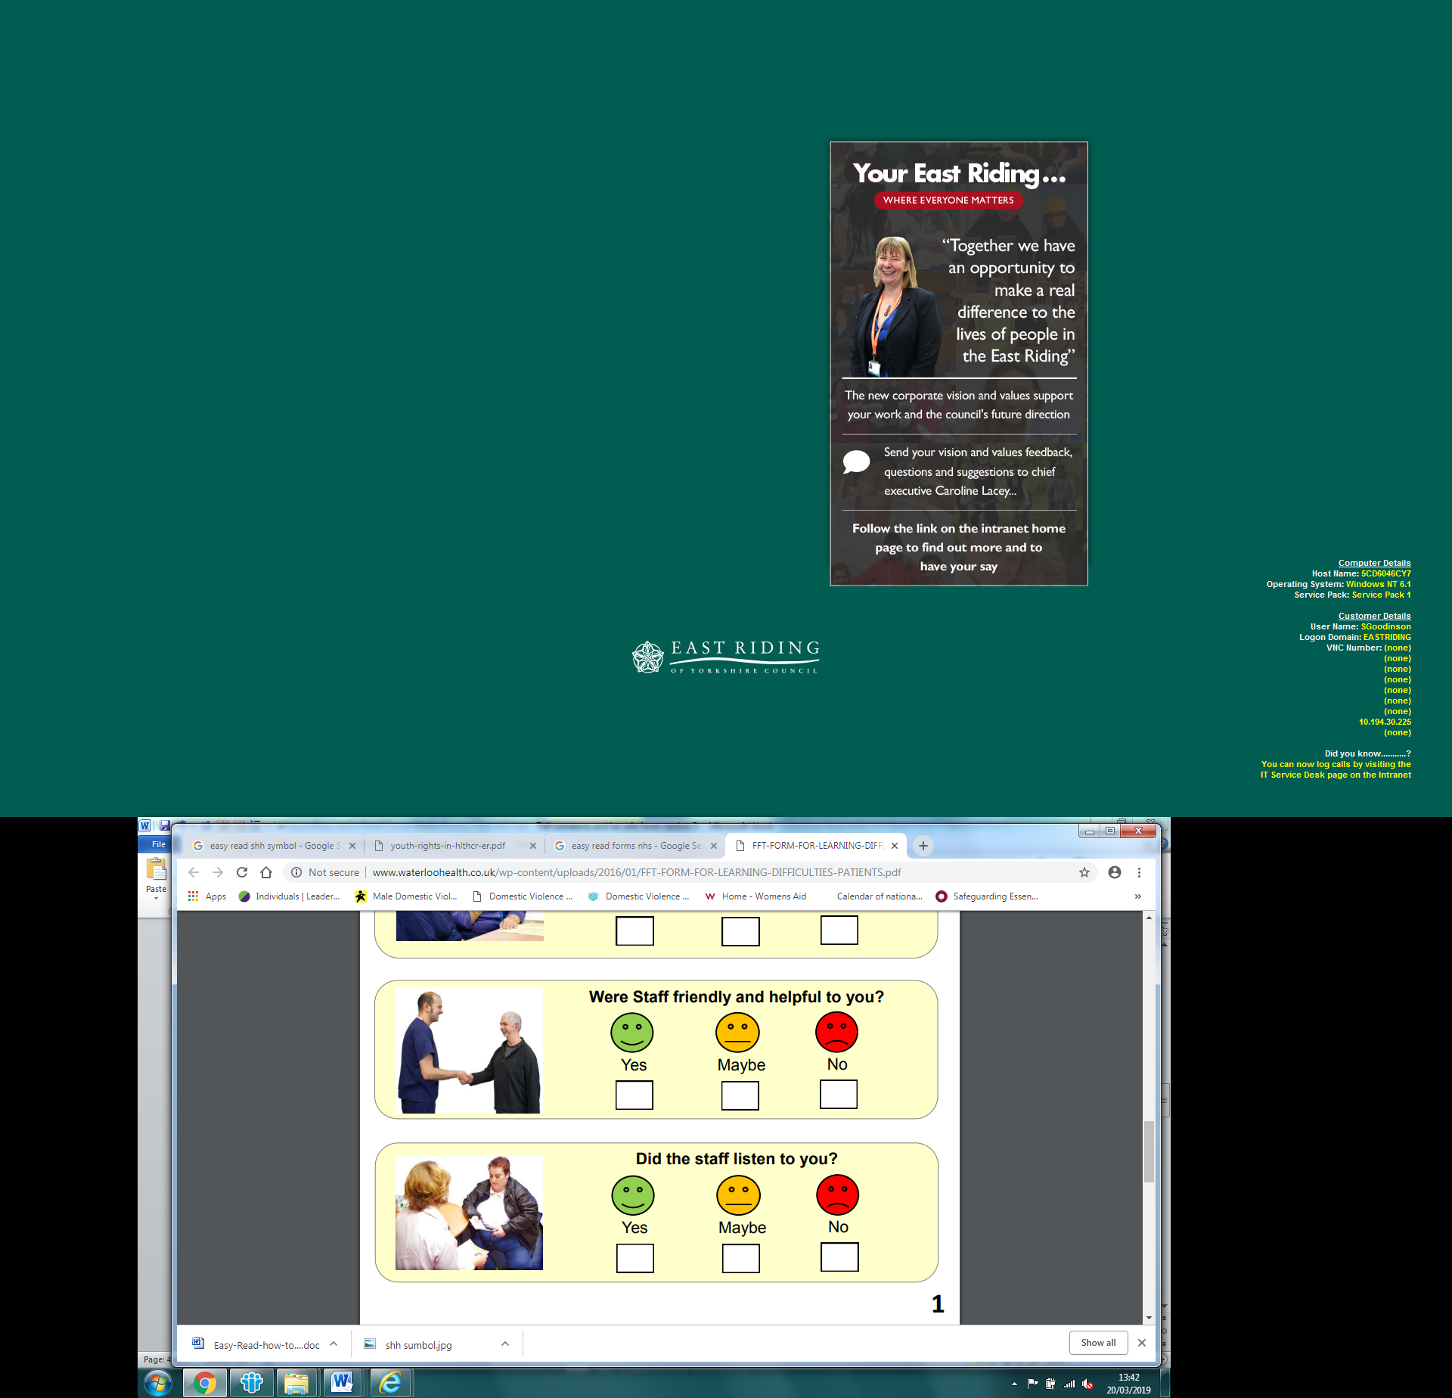



**No**



**Yes**

**What do you want to happen about this?**



**If it is someone else you are worried about:**

**What is their name?**



**Their**

**Name**

**Do you think this person would be OK with someone going to see them to help?**

**(Please circle your answer)**

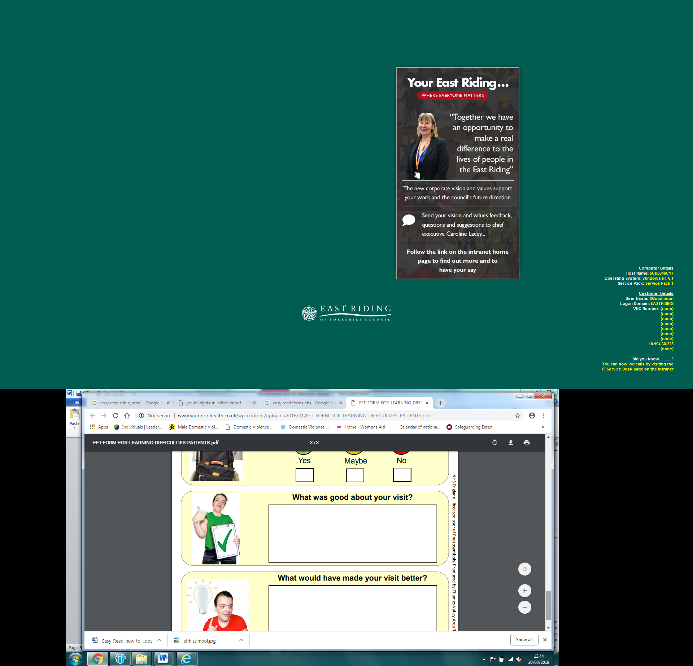



**No**



**Yes**

**What do you think they would like to happen about this?**





Thank you!



**Please give this form to someone that you trust…**

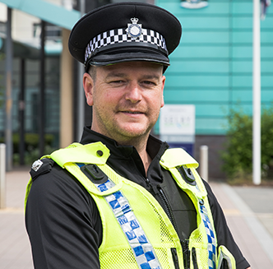

**A Police Officer**



**A Care Worker or Social Worker**

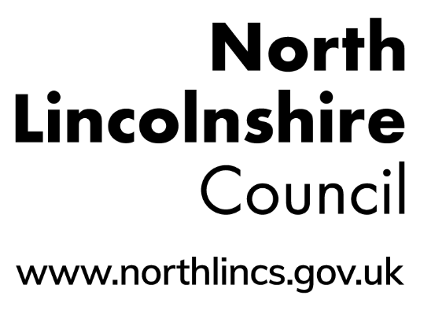

**Any Council Building**



**Your Doctor or Nurse**

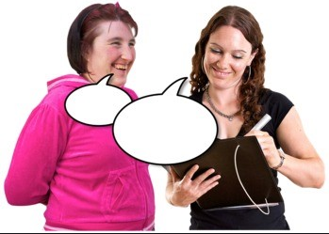

**An Advocate**

For the person receiving this form ONLY:

**Please scan the form onto a computer and email confidentially to:**

adultprotectionteam@northlincs.gov.uk

**- - - PLEASE DELETE THE FORM AFTER EMAILING - - -**

**You can also call the North Lincolnshire Safeguarding Adults Team with this information on:**

**Tel:** (01724) 297000

Monday – Thursday 9am – 5pm

Friday 9am – 4.30pm

**ABUSE IS WRONG!**

**YOU MUST ALWAYS TELL SOMEONE!**

**Do not ignore it! Report it!**



**North Lincolnshire Safeguarding Adults Board**

Website: [www.northlincssab.co.uk](http://www.northlincssab.co.uk)